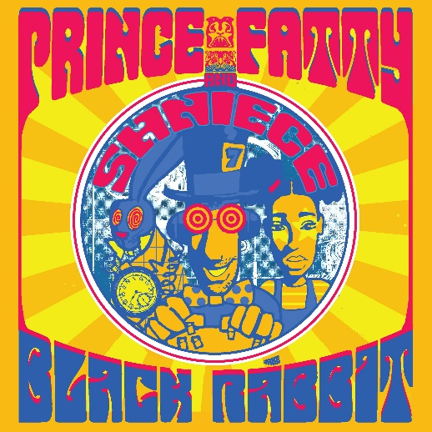
Prince Fatty and Shniece McMenamin – Black Rabbit
Release Date: 25/09/2020
Label: Evergreen Recordings
Private Soundcloud: https://bit.ly/3gL2bmK
Pre-Save: https://ffm.to/black-rabbit

Proving themselves to be one of the go-to reggae and dub duos of modern times, Prince Fatty and Shniece McMenamin have been relentlessly flexing their studio muscles lately, dropping a whole host of projects consistently for your listening pleasure. Next up is a psychedelic era anthem that goes by the name of ‘Black Rabbit,’ it’s a cover of Jefferson Airplane’s 1967 classic ‘White Rabbit’ and will be released with a dub version both digitally and on 7” vinyl on the 25th September.

After featuring on Prince Fatty’s ‘In The Viper’s Shadow’ album last year, Shniece has played a key role in Fatty’s productions ever since. They have covered Kraftwerk’s ‘The Model,’ Tom Browne’s ‘Funkin’ For Jamaica’ and also worked together on Shniece’s highly acclaimed debut EP ‘Disco Deception.’

A real journey of a record, ‘Black Rabbit’ features 60s mind bending guitar, plenty of delay and reverb with a heavy pounding hypnotic backbeat. With Shniece’s vocals taking on the melody, this is euphoric dub at its finest. On creating the record, Prince Fatty added:

“After Breaking Bad and Greys Anatomy Hollywood got to know about the Prince Fatty sound. All was quiet for a while until I got a call from a sync agent asking if I had any psychedelic “Free Love” era songs in my style for a pitch. I had to admit that I didn’t but it got me thinking which songs could be converted. A selection was drawn, and ‘White Rabbit’ by Jefferson Airplane stuck out. A masterpiece of course and quite a challenge as the vocal is so skilfully delivered.”

“A tough arrangement is always good in the studio and risks tend to bring dub rewards. Reborn as Black Rabbit in a down tempo twist featuring the immaculate Shniece McMenamin on vocals.”

Between them, Prince Fatty and Shniece McMenamin have worked alongside some of music’s most respected names. Their collaborative efforts span from Blur’s Graham Coxon to Lily Allen, Hollie Cook, The Last Poets, The Skints and Mungo’s Hi-Fi. They’ve also received heavy radio support from David Rodigan, Craig Charles and Don Letts to name a few.
It’s becoming more and more apparent that this duo has an inimitable energy that shines through on every single release.

Prince Fatty and Shniece McMenamin are down the rabbit hole – join them for a dub fairytale in the world of wonderlands!

Credits
Drums – Horseman
Percussion- Horseman and Lenny Edwards
Bass - Dub Judah
Guitar - Kashta Tafari
Keyboards - Carlton “Bubblers” Ogilvie
Vocals - Shniece McMenamin
Recorded at the Ironworks, Brighton
Mixed by Prince Fatty at “Jah Dub Stido”, Siracha, Thailand

Shniece McMenamin
https://www.facebook.com/shniecemusic
https://www.instagram.com/shniecemusic/
https://twitter.com/shniecemusic
https://spoti.fi/3eUg5TA

Prince Fatty
https://www.princefatty.co.uk/
https://www.facebook.com/princefatty
https://twitter.com/prince_fatty
https://www.instagram.com/princefattyofficial/
https://spoti.fi/2GEyXak

will@weareboutique.co.uk

